**The Fate of Indonesia’s New Capital City**

**Introduction**

Indonesia is building a new capital city—Nusantara. In 2019, President Joko Widodo (known as Jokowi) committed the country to building Nusantara on the country’s biggest island, Kalimantan (formerly Borneo). His plan was to move at least some of the government agencies there in 2024, the final year of his second term.

There is a compelling reason for building a new capital city. Jakarta has been the country’s capital since independence in 1945. It is located on the north coast of the island of Java and is by far the country’s largest city. But it is sinking while the sea is rising; it must shrink to survive.

The timing to begin the Nusantara project was unfortunate, because the Covid-19 pandemic in 2020 necessitated sharply reduced funding in the initial years of construction. When it was “inaugurated” on 17 August 2024, Nusantara was not sufficiently finished to enable any government agencies to move there.

Jokowi’s successor, Prabowo Subianto, was inaugurated in October 2024. It quickly became apparent that he would not attach the same priority to building out Nusantara. It is even possible that Nusantara will not be functioning as the seat of government by the end of Prabowo’s first term in 2029.

What can be done to avoid Nusantara from becoming a colossal failure?

**The archipelago problem**

There are only four archipelago nations in the world with populations of more than 2 million: Indonesia, Japan, Philippines, and New Zealand. Indonesia is by far the largest both in terms of population (270 million) and land area (almost 2 million square kilometers).[1]

All four of the larger archipelago nations have capitals located in coastal areas that are vulnerable to the rising oceans. Indonesia is the only one that cannot easily relocate its capital inland on the same main island, because Java is one of the most densely populated pieces of land in the world.

Another distinction is that Indonesia’s main islands are stretched across a much greater distance: 4,800 kilometers from the western tip of Sumatra to the eastern border of Indonesian Papua. This leaves only two large islands near the center of the archipelago as logical candidates for a new capital: Kalimantan and Sulawesi (formerly Celebes).

Maybe an archipelago nation could have more than one capital city. But this begs the question of why any country needs to have a capital city. It seems to boil down to just two functions. First, it helps to have all the branches of the national government (especially the ministries) in one place. Second, it wouldn’t make sense to require foreign governments to establish embassies in two different cities. These are compelling reasons for having only one capital city.

**History and Background[2]**

Jakarta has been Indonesia’s seat of government and main city for most of the years since the Dutch colonized the territory in 1815 and named this port on the north coast of the Java “Batavia”. Creating a new city to compete with Jakarta became a public policy issue on several occasions after Indonesia’s independence in 1945.

Indonesia’s first president, Sukarno, pursued the possibility of building a new capital city in the interior of the island of Kalimantan, at Palangka Raya. It became the capital of the province of Central Kalimantan in 1958 and has grown to have a population today of around 300,000. But it never found another champion to make it the country’s capital.

General Suharto pursued a plan to develop a new city (Jonggol) on Java inland from Jakarta. The vision was to move some government offices there, but it was criticized as a scheme to enrich his family and interest evaporated after Suharto was forced to step down in 1998. Among the next three presidents of Indonesia, only the third, Susilo Bambang Yudhoyono, took steps to find a possible location for a new capital, but he never got as far as choosing a site.

The construction of Jokowi’s Nusantara began in 2020 based on the plan of a young designer selected from several hundred submitted to the government. The vision was of a “forest city” in which tall trees would provide shade, solar panels would supply the needed electricity, and walkways would connect parts of the city reducing the need for cars. It would be a “smart city” and a model for the rest of the world. Its development would be fully consistent with the Sustainable Development Goals (for 2030) adopted by the United Nations. It would be designed to have a population of 1.5 million within a few decades.

A law was passed in 2020 to formalize the project. The initial cost estimate was $33 billion, most of which would come from foreign investors. To dramatize the city’s role, a monumental Presidential Palace complex was the first part to be completed. On inauguration day in August 2024, however, the number of invitees to the ceremony had to be reduced from the planned 8,000 to just 1,300, the most that could be comfortably accommodated.[3]

**The Geography**

The Indonesian archipelago is said to include roughly 17,000 islands, but there are only five large islands: in order of size, Kalimantan (the parts that do not belong to Malaysia and Brunei), Papua (the Indonesian half of the island), Sumatra, Sulawesi, and Java. The other islands are each less than 100,000 square kilometers.[4]

But the population is highly concentrated. According to the 2020 census, 52 percent of Indonesia’s total population of 270 million lived on the Java, the smallest of the five big islands. The other four big islands together held 36 percent of the population. Each of the remaining islands had populations of less than 5 million.

Administratively, Indonesia is divided into 38 provinces. Five of these provinces are on the island of Kalimantan. The province of East Kalimantan is the second largest of these five by area and the third largest by population (around 4 million in mid-2024), having only two significant cities before the construction of Nusantara: Samarinda (the provincial capital) and Balikpapan.

The province in turn is divided into 7 kabupaten. Nusantara is being built entirely within the kabupaten of Penajam Paser Utara with an area of 3.3 million square kilometers and a 2020 population of 143,000.[5] Penajam Paser Utara in turn is divided into 4 kecamatan and most of Nusantara is located within the kecamatan of Sepaku. See map.[6]

Key:

Pusat Pemerintahan = Government Core Area

Pusat Eknonomi = Core Urban Area

Kawasan Inti IKN = Core area of the IKN territory

Calon IKN = Candidate/Future territory of IKN

**An Early Assessment of the Nusantara Project**

Michael Castle-Miller is one of America’s leading scholars of new city design. We became acquainted in connection with a study of urbanization in Myanmar. This collaboration inspired us to produce an essay on how to make Indonesia’s Nusantara project a success. Our essay was published initially in the January-March issue of the *East Asia Forum Quarterly* magazine and then as a short post on the EAF blog in May 2020.**[7]**

We started by noting the strong case for building a new capital city. Among other factors, 56 percent of Indonesia’s population was urban in mid-2019 and most forecasts had its urban population ratio rising above 70 percent by 2050. This implied creating new and attractive urban communities for more than 90 million people in 30 years, hard to do simply by expanding existing cities. More to the point, global experience showed that building a new city can be substantially less expensive, for comparable quality, than expanding an existing city. Furthermore, many of Indonesia’s cities are located on coastal plains where they are vulnerable to the rising sea level due to global warming.

We shared some of the skepticism about Jokowi’s plan that greeted its announcement, but we focused on three areas where steps could be taken to improve the odds of success: making it people-centered, using Land Value Capture (LVC) tools, and creating a sound governance structure.

As we saw the project being developed by the Jokowi Administration, the emphasis was on infrastructure, not people. In particular, there were fewer than 200,000 people living in the IKN territory when construction began, including some indigenous communities.[8] Little thought was being given to making them stakeholders/beneficiaries of the project. Instead, there were well documented examples of families being displaced with little or no compensation.

We suggested a policy of land acquisition with three elements: (1) cash compensation for moving to new housing freely selected and designed by those displaced; (2) better jobs with infrastructure and building developers for people being displaced—and providing any training required by them; and (3) some form of equity in the project so that displaced people would share in the financial gains of a successful project. We pointed to Shenzhen in China as an example of a new city that has grown to have 14 million residents over a period of 40 years. We suggested that Nusantara’s development should aim to treat the initial newcomers—construction workers and civil servants—very favorably so that they would become visible promoters of new arrivals.

Then we questioned the financing model for Nusantara, with most of the cost coming from private investors. We sketched out the advantage of using Land Value Capture (LVC) tools that could yield most of the required financing locally without incurring any debt or loss of control to foreign lenders and investors. These tools have been used successfully in many countries over the past 20-30 years. These tools divert the increasing land value associated with a project’s infrastructure development to the government instead of lining the pockets of speculators who buy up the land cheaply before construction starts. The simplest form of LVC is for the government to acquire the land and then raise rents as market demand allows. Other forms are methods of land-value taxation that encourage owners to improve their land instead of simply waiting to sell at a profit once its value has risen.

Finally, we warned that the biggest threat to the success of the project could be political interference by wealthy and powerful parties able to enrich themselves from construction contracts or real estate speculation. Here we noted reports, subsequently verified, that the current president of Indonesia (Prabowo Subianto) along with family members and close friends were owners of large portions of the land in the project territory.

We stressed the potential benefits of creating a governance system along the lines of the “charter cities” proposed by the Nobel economist Paul Romer. Such a system would vest power initially in a group of non-political technocrats committed to best practices for design, transparency, and accountability. The governance system would then evolve as the project succeeded and governance in the rest of the country improved.

We closed with the suggestion that the project could be recast as simply the creation of a new city, with the decision to make it the nation’s capital coming after the project has generally been viewed as successful.

**Impressions from a Visit in October 2023**

I had the privilege of visiting the Nusantara project in October 2023, with the benefit of an introduction from the Indonesian embassy in Washington DC. I spent three nights in Balikpapan, checked in with the IKN Authority (Otorita Ibu Kota Nusantara-OIKN) on my first full day there, and drove to the project in a hired taxi on the second full day.

My first reaction was being shocked by the terrain. Nusantara is being built on a sandy/clay soil that has eroded over centuries to form sharp hills and valleys. On the pre-existing 2-lane road, branching off from the 4-lane divided highway between Balikpapan and Samarinda, there seemed to be less than 50 meters of buildable space on each side of the road as it passed along ridges and through valleys. Because the ground is not rocky, the hills can be leveled relatively easily with bulldozers, but this terrain has two enormous disadvantages. First, the building costs must be a multiple of what they would be on less hilly land. Second, it will not be possible to flatten the terrain enough to make mobility easy in Nusantara for pedestrians and bicycles and scooters. (See Photo A.)

Travel on the 2-lane road was slow because of trucks that climbed the hills at a snail’s pace in low gear. A 4-lane divided highway was under construction, but it made me wonder why the project hadn’t started with the construction of the highway. It would have reduced costs and speeded up construction significantly.

I have no expertise in urban design, but there was one feature of the adopted design that struck me as a bad choice. The centerpiece of the core area is a massive Presidential Palace. (See Photo B.) President Jokowi grew up in a quite modest family and rose to the presidency with a style that was simple and much appreciated by the populace. Nusantara’s Presidential Palace seems out of character and even a symptom of hubris that could end up as an architectural “white elephant”. Wouldn’t it have been better to make the centerpiece a “national monument” like the Monas in the middle of Merdeka Park in Jakarta?

The pace of construction I saw was impressive, but it left me with no confidence that Nusantara would be a livable place by the end of 2024.

With respect to the advice contained in my co-authored essay with Michael Castle-Miller, my takeaways were:

--No evidence that the approach is “people-centered”. Instead, the worst evidence came from a young official from the Ministry of Public Works who had been assigned to work on the Nusantara project. The treatment she and her colleagues were getting was bad enough to make her consider resigning.

--No evidence that Land Value Taxation or anything comparable was being implemented. However, I was unable to find anyone who had any knowledge about how the IKN Authority was addressing the panoply of land ownership, land use, and land taxation issues.

--Some evidence that the governance structure for Nusantara could be effective because it was designed (in the legislation) to be more technocratic than political. It appeared, however, that the people chosen to lead the project were responding more to the whims of the political elite than to the people currently living in the project area and potential new residents of the capital.

**Current Status[9]**

Jokowi’s successor, Prabowo Subianto, was inaugurated on 20 October 2024. Having been the Vice President in Jokowi’s second term and having Jokowi’s full support in his election campaign, there was an expectation that Prabowo would be compelled to attach a high priority to the Nusantara project, as Jokowi’s main legacy. It soon became apparent, however, that the Nusantara build out would be slow tracked by Prabowo.

For example, the *Jakarta Post* in mid-February 2025 reported that the budget for IKN had been frozen.[10] It was already clear that the amount allocated for IKN in the current budget was insufficient to maintain the pace of development envisioned by Jokowi. Moreover, the large amounts of foreign investment required to build out the capital were not materializing.[11]

Another potentially significant setback is the Trump Administration’s actions to shut down the US Agency for International Development (USAID). The Biden Administration had announced a number of USAID-funded projects to support IKN as a smart and environmentally sound project and these seem to be early victims of Elon Musk’s chainsaw. Perhaps more fatally, Jokowi’s approval among the population has been slipping from its peak of 82 percent in July 2024.

One overarching problem is that the Indonesian economy is not looking strong, and it is vulnerable to the shocks to the global economy emanating from the Trump Administration in Washington DC. Prabowo has pledged to raise the GDP growth rate to 8 percent from its decades-long trend of 5 percent annually. No reputable economist believes this target is realistic.

Already Prabowo’s Administration is losing support from new corruption scandals and serious problems, among others the rollout of his top priority of providing free meals to all of Indonesia’s students.

One unanticipated problem is the sweeping reorganization of government ministries related to Prabowo’s decision to greatly increase the size of his cabinet. This is substantially complicating the movement of civil servants from Jakarta to Nusantara.[12]

Domestic critics of the Nusantara project are continuing to attack it for mistreating the indigenous residents of the territory and for a host of other concerns from water supply to encroaching on wildlife habitat (notably for the orangutan monkeys).[13] Here is one of the sharpest criticisms of the project’s environmental impact: “. . . the new eco-capital will likely be funded by burning vast amounts of coal to refine nickel in processes that produce huge amounts of slag and greenhouse gas emissions, all to provide batteries for electric cars.”[14]

The Achilles Heel of the Nusantara project could be the issues of land ownership, land use, and land taxation. To begin with, large tracts of land within the project area have been awarded to mining and plantation (palm oil) concessions. Here as well as in the rest of the country, land records are incomplete and contested, especially for the indigenous communities. Wealthy and powerful interests not only have acquired large holdings within the project territory, but they also have the ability to manipulate the system to their pecuniary advantage. This is likely to become a major obstacle to populating the territory with voluntary, spontaneous migrants.

It is worth stressing that criticism of the Nusantara project has been at least as vigorous from inside Indonesian sources as from outside sources. For example, an edited book co-published in 2023 by ISEAS-Yusof Ishak Institute in Singapore and BRIN (the National Research and Innovation Agency of the Indonesian government) includes these trenchant remarks:[15]

* “. . . separating Indonesia’s historical centre of executive power and national government from a cosmopolitan ‘nation in microcosm’ megacity [Jakarta] will re-spatialize, and in doing so consolidate, trends towards more unaccountable and inaccessible forms of state power.” (p. 54)
* “Nusantara . . . could be seen as a spatial consolidation of elite-driven erosions of Indonesia’s democratic gains.” (p. 63)
* “. . . Indonesia needs to be vigilant of similar processes happening in the cities of Java, where capitalistic urbanization has prevented the production of socially inclusive and environmentally sound urban spaces.” (p. 119)
* “[The IKN Law] continues to stir criticism, including the vast project’s potential for environmental damage and accusations of land grabbing, ‘whitewashing’ the obligations of mining companies, and the exclusion of indigenous people”. (p126)

**The Best That Can Be Done Now**

Stressing that I have no urban planning expertise, my thoughts on how to proceed are based on: (1) 50 years of work as an economist observing firsthand Indonesia’s economic development since my first visit in 1967; (2) two years on the USAID staff in the Jakarta Mission—1971-73, and (3) as many as 15 trips to Indonesia since then. In no particular order:

1. Drop the big funding number for building out Nusantara. It is unlikely to materialize in the project time frame and simply makes the government look bad as the actual numbers are reported.
2. Stop seeking funding from foreign investors. Getting foreign investors to commit to a project like Nusantara often requires incentives like tax holidays that do not produce benefits commensurate with the budget costs.
3. Grow the new city organically with no deadlines. This means, above all, focusing on the people.
4. Address effectively the issues of land ownership, land use, and land taxation. To begin with, make current ownership and use fully transparent.
5. Treat indigenous communities with respect. Make sure they are generously compensated for any land acquired from them. Make sure they have alternative employment if they are unable to continue their traditional occupations. Give them an equity interest in the success of the IKN project.
6. Make living in Nusantara attractive for the civil servants who will be moving there. At least ensure that they are financially better off living there than in Jakarta. Give priority to building markets, schools, and hospitals that make Nusantara an above-average place to raise a family.
7. Never promise to do something that has less than a 90 percent chance of being achieved. One of the classic governing mistakes is overpromising. By contrast, exceeding targets is one of the best ways of ensuring a project’s success.
8. Do not get caught up in hypes and the fads like smart city, sustainable city, forest city, etc. Instead proceed thoughtfully and at a moderate pace. Innovation and experimentation are good, especially if home grown. Don’t waste money on foreign experts. Avoid committing to foreign-funded activities that reflect donor priorities and are not aligned with real needs. Be inspired by innovative urban projects, like a new community in Chengdu, China by the architect Liu Jiakun who won the Pritzker Prize in 2025. (See photo C)
9. Be noncommittal about declaring Nusantara the capital and making it the primary residence of the President. Leave this decision on hold for at least 10 years in the future when a future President and his/her family and friends decide that living in Nusantara will be better than living in Jakarta. Don’t worry if “the capital” remains in Jakarta as long as Nusantara is successful in becoming Indonesia’s most livable and dynamic city.
10. Never let vested interests take advantage of the project to become wealthier at the expense of the rest of the population. Succeeding will require a governing authority that is able to resist the corruption and rent-seeking endemic in Indonesian culture.

Photo A 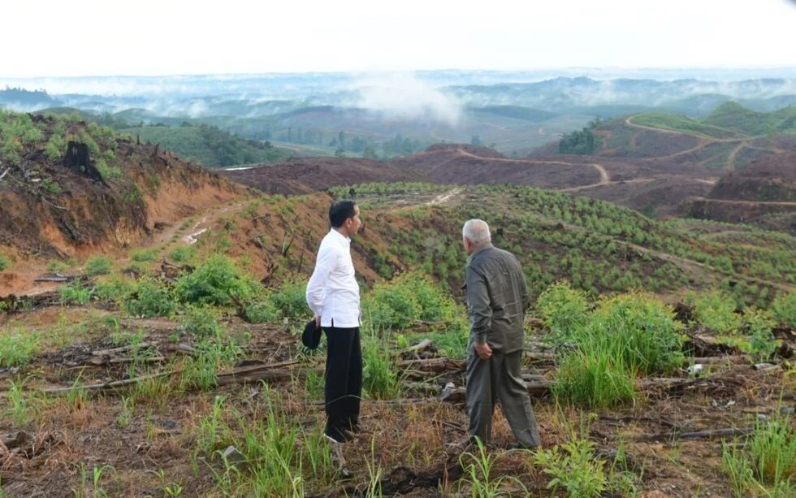

From:

<https://th.boell.org/en/2024/09/19/nusantara-milestone-setback> [accessed 1 March 2025)

Photo B 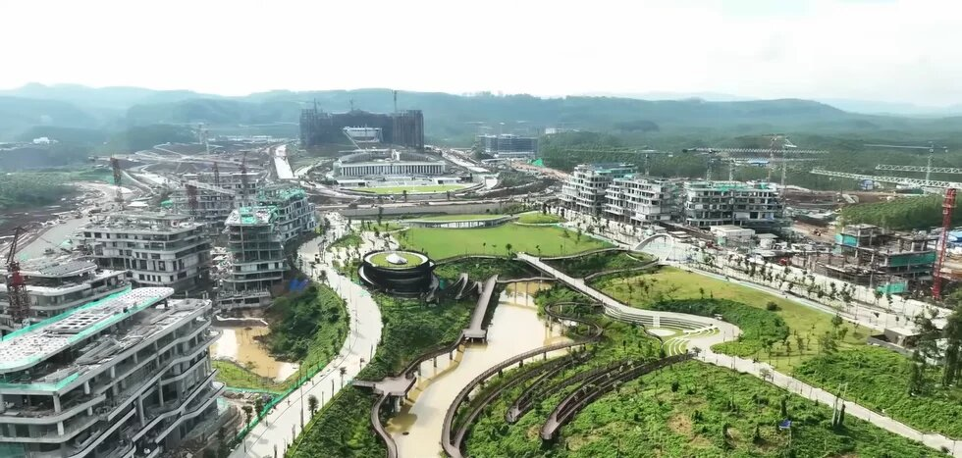

From: <https://en.wikipedia.org/wiki/Nusantara_(city)#:~:text=NASA's%20February%202024%20Landsat,and%20southward%20to%20Balikpapan%20Bay>. [accessed 10 March 2025]

Photo C

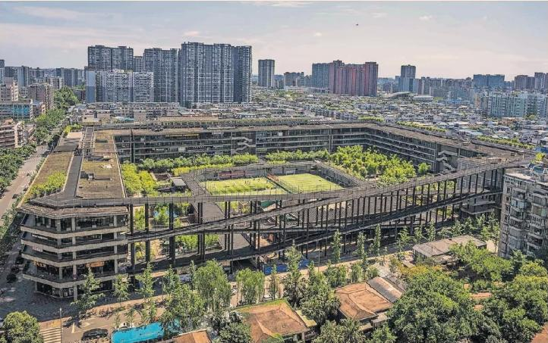

From:

<https://ft.pressreader.com/v99e/20250305/281749865109040> [accessed 11 March 2025]

1. <https://en.wikipedia.org/wiki/List_of_island_countries> [accessed 26 February 2025]
2. An important source is Robert Templer, *Nusantara: Indonesia Builds A New Capital*, Bui Jones publishing, 2024, 107p.
3. <https://time.com/7015043/indonesia-new-capital-nusantara-construction-jokowi-legacy-limbo/> [accessed 1 March 2025]
4. <https://en.wikipedia.org/wiki/List_of_Indonesian_islands_by_area> [accessed 28 March 2025]. Other numbers from Wikipedia.
5. Detailed information about the local population in the IKN territory can be found here: <https://ap.fftc.org.tw/article/3484> [accessed 1 April 2025]
6. <https://www.instagram.com/p/CfA4PPmsiYX/?igsh=bGllbXFsOGg3ZHl5> [accessed 1 April 2025]
7. *East Asia Forum Quarterly*, Vol. 12, No. 1, January-March 2020, “Building Indonesia’s New Capital”. EAF blog datelined 22 May 2020 with the same title: <https://eastasiaforum.org/2020/05/22/building-indonesias-new-capital/>

   [accessed 4 March 2025]
8. <https://ppukab.bps.go.id/id/statistics-table/2/MzMyIzI=/-sp2020-jumlah-penduduk-menurut-kecamatan-dan-jenis-kelamin.html> [accessed 1 April 2025]
9. The website for the Nusantara project is <https://www.ikn.go.id> [accessed 30 March 2025]
10. <https://www.thejakartapost.com/indonesia/2025/02/12/ikn-budget-freeze-raises-doubts-about-prabowo-jokowi-ties.html> [accessed 2 March 2025] A few weeks later, IKN was designated in a Presidential Regulation as one of 77 “National Strategic Projects”, suggesting it would get the funding needed to maintain momentum. See <https://ikn.kompas.com/read/2025/03/06/053000187/ikn-resmi-jadi-proyek-strategis-nasional-prabowo-dukung-penuh?lgn_method=google&google_btn=onetap> [accessed 7 March 2025]
11. <https://www.thejakartapost.com/business/2025/02/26/ikn-authority-admits-less-than-half-of-lois-represent-real-investment-proposals.html> [accessed 10 March 2025]
12. <https://www.thejakartapost.com/indonesia/2025/01/08/no-plan-to-relocate-civil-servants-to-nusantara-soon-minister.html> [accessed 10 March 2025]
13. <https://eastasiaforum.org/2024/09/21/displaced-indigenous-women-bear-the-brunt-of-indonesias-capital-city-project/> [accessed 10 March 2025]

    An August 2024 assessment of the IKN project by staff members at ISEAS-Singapore can be found here:

    <https://www.iseas.edu.sg/wp-content/uploads/2024/06/ISEAS_Perspective_2024_59.pdf> [accessed 2 April 2025]
14. Templar, op. cit, p. 84
15. Julia M. Lau, Athiqah Nur Alami, Siwage Dharma Negara and Yanuar Nugroho (eds.), *The Road to Nusantara: Process Challenges and Opportunities*, BRIN and ISEAS,2023.